

***Operating Systems***

***Lab Work***

***Practical 3***

***Name :Shrey Vyas***

***Batch:F-1***

***Roll Number:22BCE335***

1.

Series2.sh file(while loop):

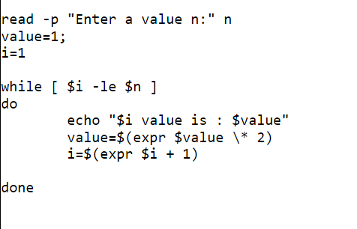

Series2.sh file(until loop):

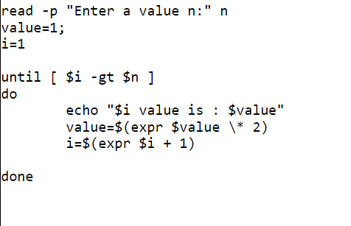

Output:

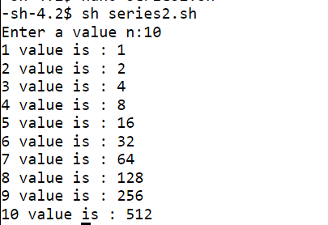

2. combination of 2 numbers:

combination.sh file:

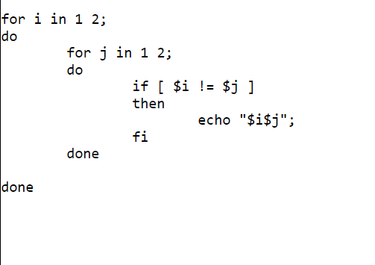

Output:



Combination of 3 numbers:

combination.sh file:

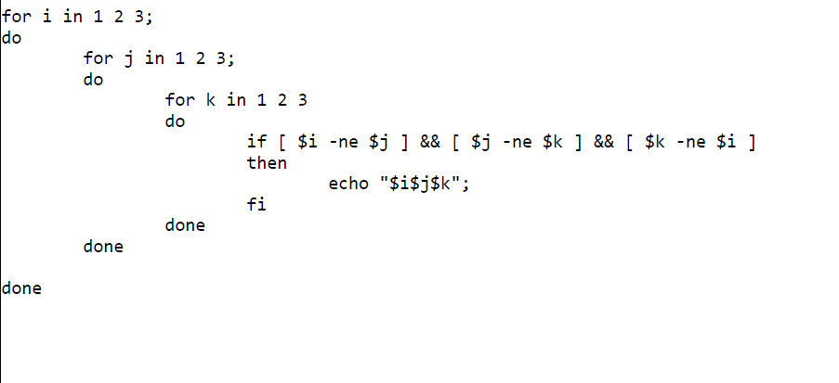

Output:

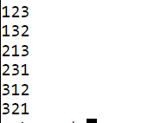

Combination of 5 numbers:

combination2.sh file:

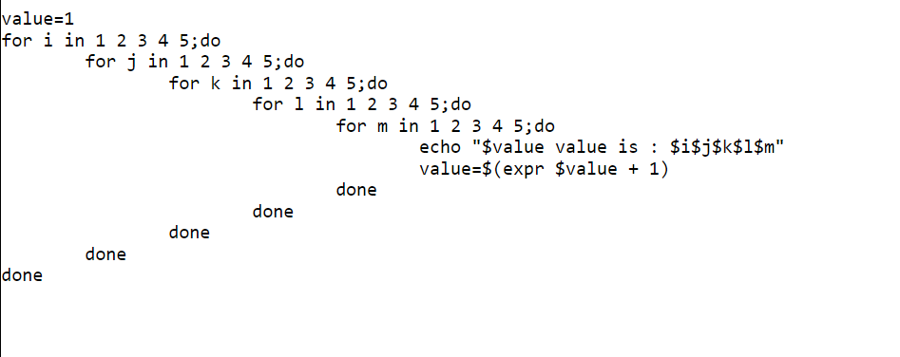

Output(Only the end part):

